PROJECT DEVELOPMENT PHASE

SPRINT 4

|  |  |
| --- | --- |
| Date | 12 November 2022 |
| Team ID | PNT2022TMID22872 |
| Project name | Real –time river water quality monitoring and control system |
| Maximum marks | 4 marks |

|  |  |
| --- | --- |
|  |  |

MOBILE APPLICATION

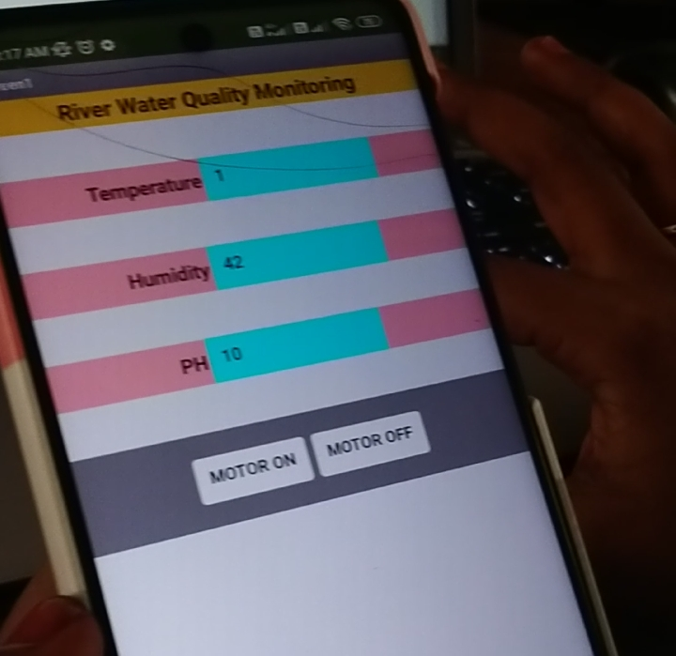

PROJECT DESIGN PHASE 1

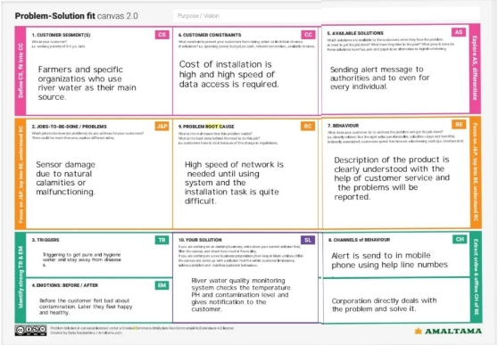

PROPOSED SOLUTION

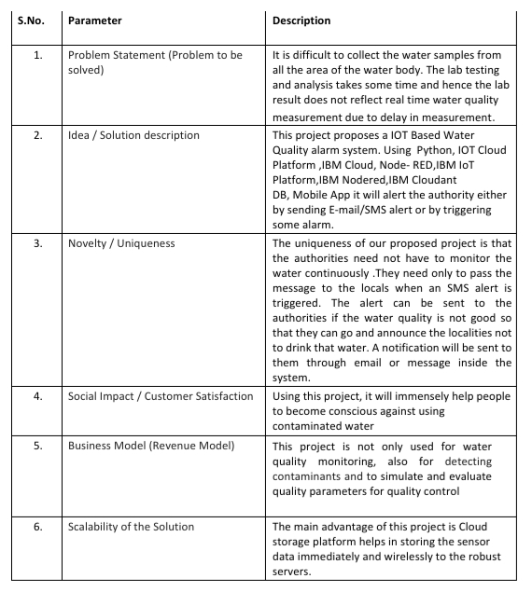

SOLUTION ARCHITECTURE

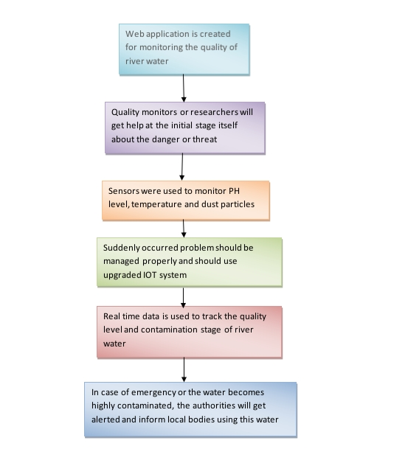

PROJECT DESIGN PHASE 2

CUSTOMER JOURNEY

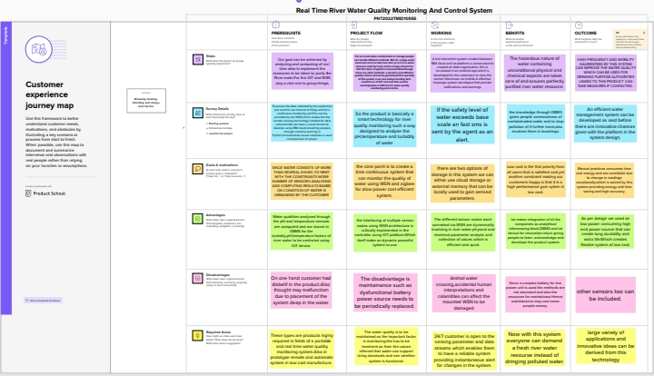

DATA FLOW DIAGRAM

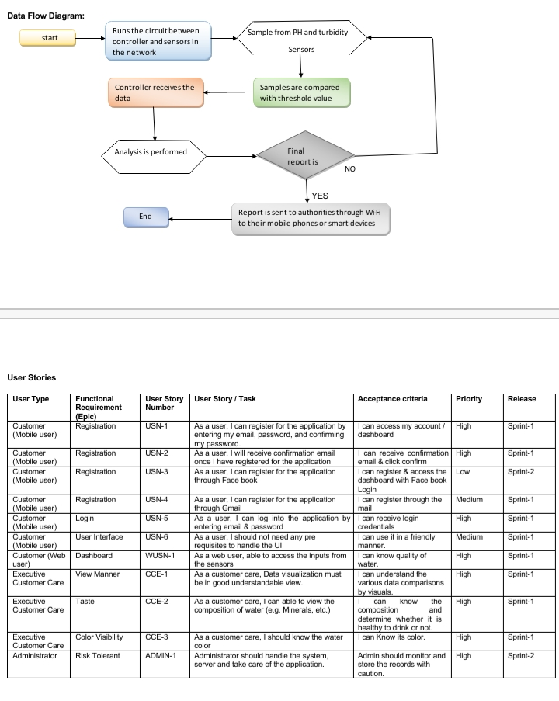

FUNCTIONAL REQUIREMENTS

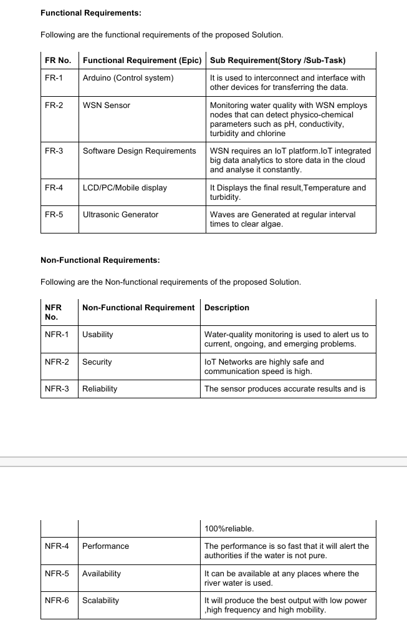

TECHNOLOGY ARCHITECTURE

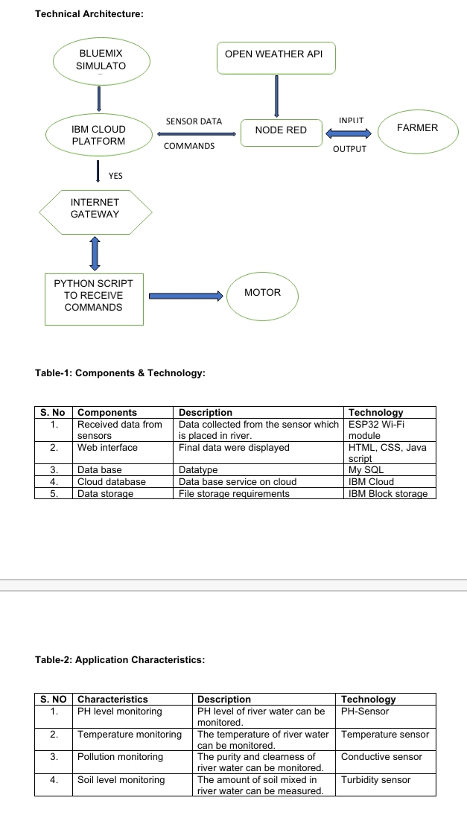

MILESTONE AND ACTIVITY LIST



SPRINT DELIVERY PLAN

